CompTia A+
A+ - Understanding and maintenance of Networks

Assignment-1
Day 1: Introduction to Networking HardwareTheory (1 hour):Overview of modems, routers, switches, access points, and network cables.
QUE-01 Draw a labeled diagram of a typical home Wi-Fi setup showing a modem, router, switch, access point, and at least two devices (like a laptop and smartphone) connected to the network.
ANS
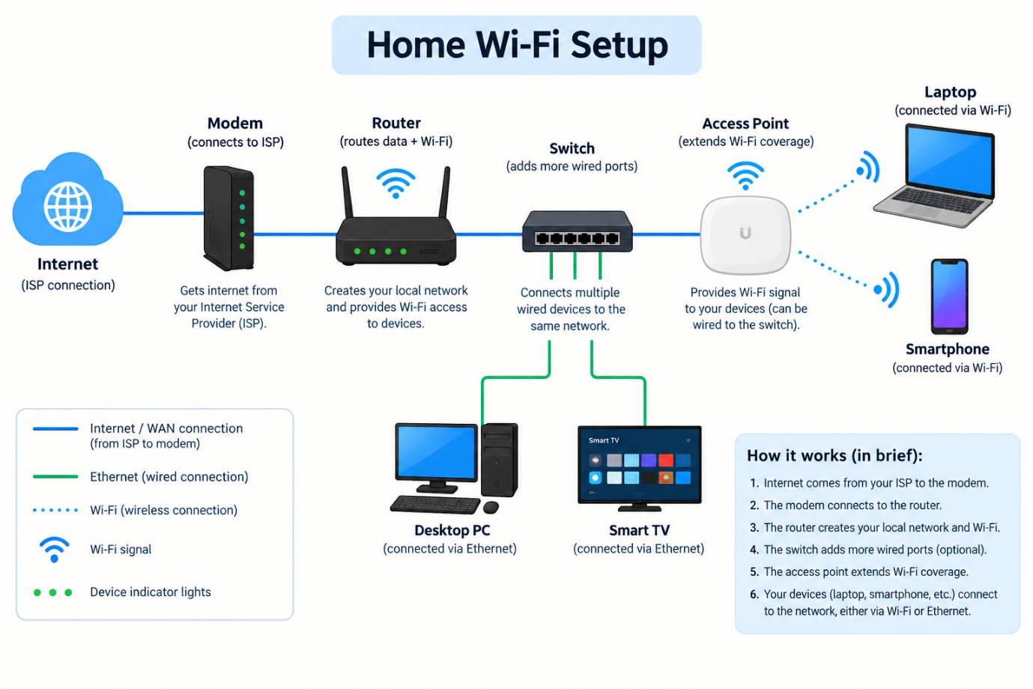

QUE-02 List the main function of each networking hardware device: modem, router, switch, access point, and network cable. For each, give a real-life example of where you might see or use it (for example, 'router: at home to share internet').
ANS
Networking Device | Main Function | Real-Life Example
1. Modem | Connects your home or office network to the internet service provider (ISP). | Used at home to receive an internet connection from a provider like Jio or Airtel.
2. Router | Directs data between networks and shares the internet with multiple devices. | Used at home to connect laptops, smartphones, and smart TVs to the internet.
3. Switch | Connects multiple wired devices within the same local area network (LAN). | Used in an office to connect multiple computers and printers using Ethernet cables.
4. Access Point (AP) | Provides Wi-Fi connectivity to wireless devices and extends wireless coverage. | Used in a college to provide Wi-Fi in classrooms and corridors.
5. Network Cable | Carries data between network devices through a wired connection. | An Ethernet cable connects a desktop computer to a router or switch.

QUE-03 Take photos or find images online (with source links) of at least three types of network cables (such as Ethernet, coaxial, fiber optic) and write one line describing where each is commonly used.
ANS
1. Ethernet Cable (Twisted-Pair)
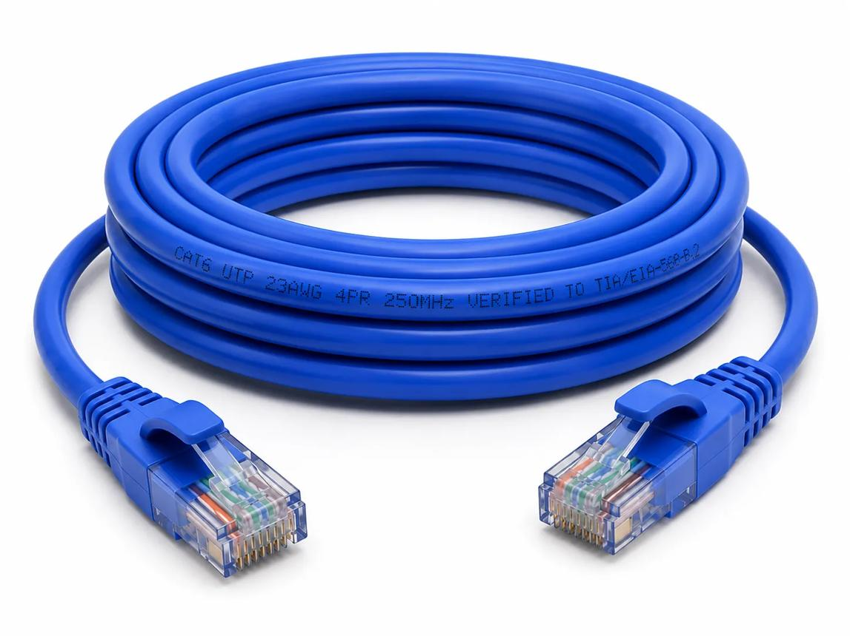
Description: Ethernet cables are commonly used to connect computers, routers, and switches in home and office networks.
Source: NC State University – Network Media
E 115: Introduction to Computing Environments

2. Coaxial Cable
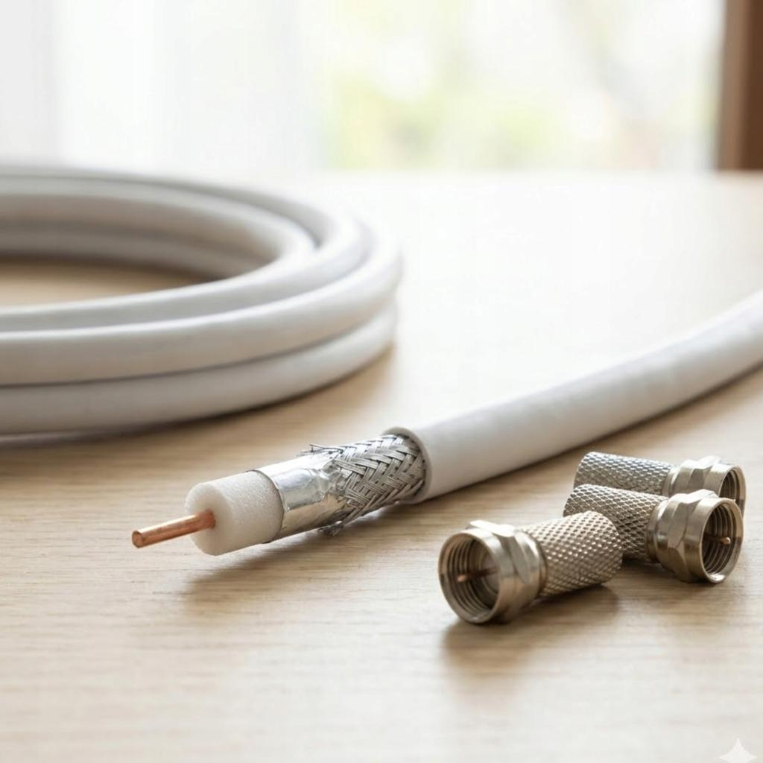
Description: Coaxial cables are commonly used for cable television, CCTV systems, and some broadband internet connections.
Source: Fiber Optic Association – Coaxial Cable Uses
Coax Cable in Premises Cabling -
3. Fiber-Optic Cable
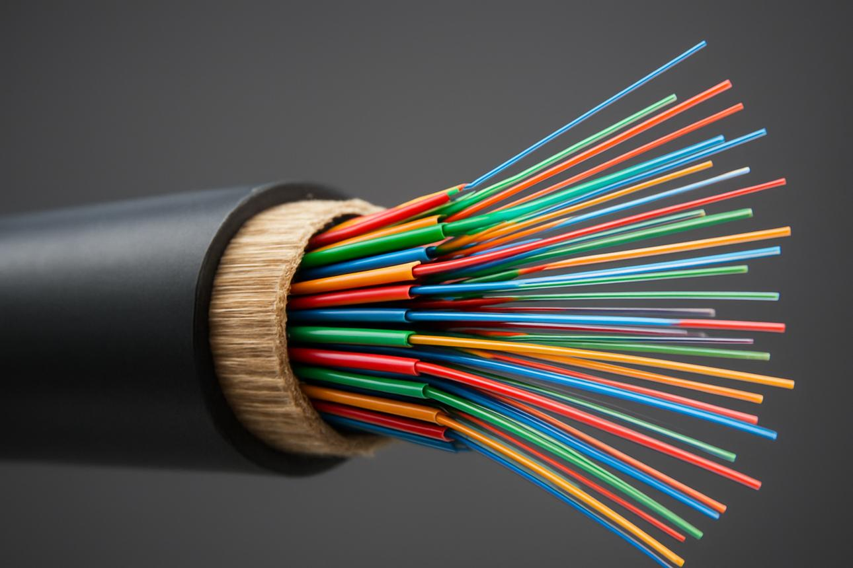
Description: Fiber-optic cables transmit data using light and are commonly used for high-speed internet, telecommunications, and long-distance connections.
Source: Open University – Network Media
QUE-04 Create a comparison table listing at least four differences between a router and a switch, including their main use, typical location, and how they handle data.
ANS
Comparison Between Router and Switch
Basis | Router | Switch
1. Main Use | Connects different networks and routes data between them. | Connects multiple devices within the same local area network (LAN).
2. Typical Location | Commonly used in homes and offices to share an internet connection. | Commonly used in office networks, computer labs, and server rooms.
3. How It Handles Data | Uses IP addresses to determine the best route for data packets. | Usually uses MAC addresses to forward Ethernet frames to the correct device.
4. Network Connection | Connects different networks, such as a home network and the internet. | Connects devices within the same LAN.
5. Internet Access | Often provides internet access to multiple devices. | Does not typically provide internet access by itself; it connects devices to a network.
6. Example | A home Wi-Fi router sharing internet with laptops and smartphones. | A switch connecting several desktop computers in a college computer lab.

